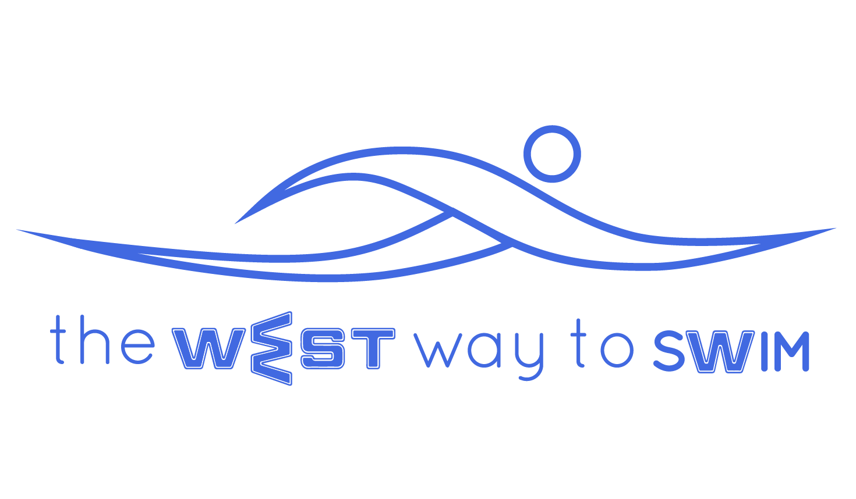
6.0 The goal of session #6:
Swimming 200 meters continuously, mastering varying pulse rates between 65%-85% for 50 meters, sending the results of 500 meter test. The total time of the training is 70 minutes.
No | The Drill & Goals | Duration in min | WEST Key Principles | From theory to practice
6.1 | 200-400 meters freestyle with fins: 2 lengths superman position, 2 lengths 10-12 strokes per length. | 8 | KP12 + 3.4 - Breathing position | Swim freestyle with fins: 2 lengths in breathing position, a different hand leading in each length, and 2 lengths full freestyle with breathing every 3 strokes while thinking of 10-12 strokes per length.
6.2 | (4X25)X2 ET 1:00  1st set: Minimum number of strokes per length  2nd set: increasing pace 1-4 | 8 | ET= Exit Time  Swimming time+ resting time=ET | 1st set: Swim 4 times 25m, thinking only of minimum number of strokes per length. The emphasys here is on staying at the end of the stretch for as long as possible. Exit time will be 1 min, so if it took you 32 sec to swim 25m, you will rest for exactly 28 sec.  2nd set: Swim 4 times 25m increasing pace from 1-4 - the first length slow and the following lengths faster and faster. Also exit time of 1 min.
6.3 | (4X50)X2 ET 2:00 Increasing from 1-4 / 5-8 | 16 |  | Swim 4 times 50m ascending from 1-4 - the first length slow (50%) and the following lengths faster and faster (65%, 75%, 85%). There should be a difference of apx 4 sec between each 50m. Exit time of 2 min.  Repeat set.  In the time you have left after completing 2 sets you can breath or stretch.
6.4 | 200-400 with fins, 12 strokes with an accurate streamline off the wall. | 8 | KP9- Accurate streamline, according to personal WEST | Swim 200-400 with fins (8 min), breathing every 3 strokes with exactly 12 strokes per length, and each time you push off the wall you do so in a streamline position according to your personal WEST.  Streamline glide off the wall according to personal WEST:  A - Glide off the wall with no legwork and stretch to the maximum for 3 sec, then continue swimming.  B - Glide off the wall while kicking your legs and then add arm strokes.  C - Glide off the wall with 2-4 dolphin moves and then continue swimming.
6.5 | 4X50 20 with second rest between 50’s + 200-400 continuous swimming. | 14 |  | Swim 4 times 50m, breathing every 3 strokes at a 65-75% pace.  Between each 50 do a different stretch each time for 20 sec.  In the end swim freestyle continuously until you get tired or the end of your 14 min.
6.6 | 1st set: 4X25 Freestyle, without breath.Minimum number of strokes.  2nd set: 4X25 freestyle, breathing every 3. Minimum number of strokes.  Both sets - concentrating on a different KP every length. | 8 | KP1- Shape of palm  KP5- Depth of stretch  KP6- Dragging legs  KP8- Depth of head in water | 1st set: Swim 4X25 Freestyle, without breathing (or as little as possible). The goal is minimum number of strokes. Each length concentrate on a different KP: First length - shape of palm, second length -depth of stretch, third length - dragging your legs, and fourth length - the depth of your head in the water  2nd set: 4X25 freestyle, breathing every 3. Minimum number of strokes, concentrating on a different KP every length as above.  Between each 25 m 15-25 seconds rest
6.7 | Stretching | 8 |  | Try to do 4 minutes arm stretches and 4 more minutes leg stretches, each stretch for exactly 10 seconds for each arm or leg.
6.8 This session is carried out twice, on the third session you switch 6.3- 6.6 and add a 500 meter test and send us your average stroke rate per length + the time it took to swim 500 meters and a video of you swimming 25 meters freestyle (If the pool is not 25 meters, please note and inform us the length of the pool).
6.9 Weekly Tip: Swimming at a high pace while maintaining a low stroke rate will prevent you from feeling tired right at the start.

